­­­**Thriving in employment services:** your rights,   
your future.

A guide for young people by the National Collaboration on Employment and Disability Youth Advisory team.

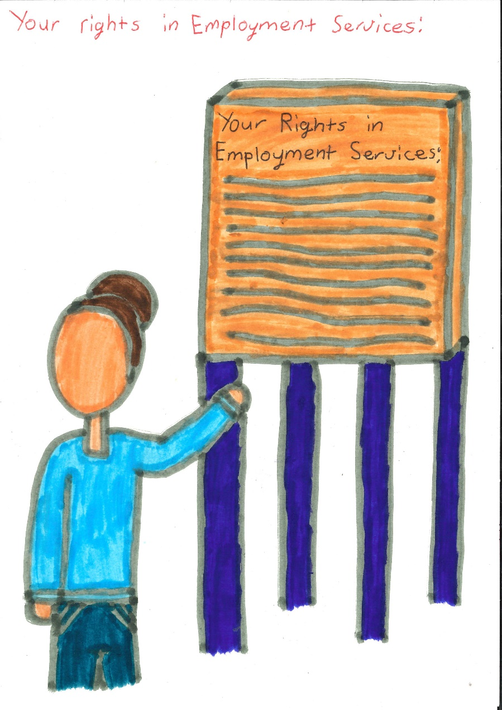

The Brotherhood of St. Laurence (BSL) is a social justice organisation working towards an Australia free of poverty. Our purpose is to advance a fair Australia through our leadership on policy reform, our partnerships with communities and the quality of our services. Our approach is informed directly by people experiencing disadvantage and uses evidence drawn from our research, together with insights from our programs and services, to develop practical solutions that work. For more information visit <[www.bsl.org.au](http://www.bsl.org.au)> or <[www.nced.org.au](https://bslau.sharepoint.com/teams/youth/YouthTransitionsToWork/NCED%20&%20IPE/PRF%20Inclusive%20Pathways%20to%20Employment%20Pilot%20(IPE)/IPE%20Practice%20Team/Youth%20Advisors/YA%20Webpage/www.nced.org.au)>.

Rhianna Malas, Kayla Sheridan and Chloe Sumner wrote this as the youth advisory team, for the Inclusive Pathways to Employment Pilot program and the National Collaboration on Employment and Disability. Kayla Sheridan created drew the pictures.

Published by

Brotherhood of St. Laurence

67 Brunswick Street

Fitzroy, Victoria 3065

Australia

ABN 24 603 467 024

ARBN 100 042 822

Ph: (03) 9483 1183

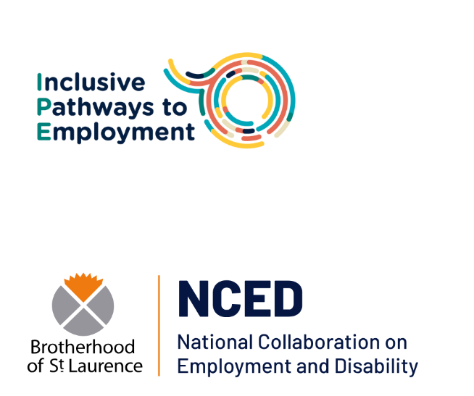

[www.nced.org.au](https://bslau.sharepoint.com/teams/youth/YouthTransitionsToWork/NCED%20&%20IPE/PRF%20Inclusive%20Pathways%20to%20Employment%20Pilot%20(IPE)/IPE%20Practice%20Team/Youth%20Advisors/YA%20Webpage/www.nced.org.au) | [www.bsl.org.au](http://www.bsl.org.au)

Suggested citation: Malas, R, Sheridan, K, and Sumner, C, 2025, ‘*Thriving in employment services: your rights, your future’ guide for young people*, Brotherhood of St. Laurence, Fitzroy, Vic.

© Brotherhood of St. Laurence 2025

Apart from fair dealing for the purpose of private study, research, criticism, or review, as permitted under the *Copyright Act 1968* and subsequent amendments, no part of this paper may be reproduced by any process without written permission. Enquiries should be addressed to the publisher.

Contents

Introduction 4

The right to dream big 5

Your right to have information that is easy to understand 6

You have the right to be heard 7

Your right to have your conditions for success understood 8

Your right to know all that's available to you 9

Your right to access opportunities to build your skills 10

Your right to have a support person with you 11

Who might make a good support person? 11

Your right to make a complaint 12

Your right to change employment services 13

How to evaluate job providers: spotting red and green flags for the support you deserve 14

# Introduction

Finding a job is a huge step in your young adult life but getting one might not be as easy as you would like. Luckily, you don’t have to figure it all out on your own. Employment services are there to help and support you through the whole process.

Employment services can help you with many things like:

* Figuring out what career paths match your interests and goals
* Finding jobs that match your skills and what you would like to do
* Connecting you with training and skill-building opportunities
* Helping you with job applications, writing cover letters, updating your resume, or getting paperwork, such as police checks or a working with children check, ready.

If you have questions or worries about any part of the job seeking process, from filling out the application and attending the interview, to onboarding and settling into a position once you are successful, it’s your employment service provider’s job to support you.

This webpage was created by the Youth Advisory Team at the National Collaboration of Employment and Disability. We’ve put together this guide to help young people like you with:

* How to spot the green and red flags when choosing a job provider
* Knowing your rights and how to speak up for yourself
* Understanding what you need to succeed and finding opportunities that work for you
* And much more!

We hope this guide will help to build your confidence, dream big and go after what you want!

# The right to dream big

No one has the right to tell you that you cannot chase a career pathway that excites you or that you’re passionate about. You know yourself best and you have the same rights as everyone else to dream big and be able to follow a career pathway that aligns with your goals.

Dreaming big also means you have the freedom to explore different career paths. Even if you're unsure exactly what you want, you have the right to experiment, try new things, and figure it out along the way. The journey is just as important as the destination.

It’s important to think about the difference between your dream job and a survival job. Sometimes we just need to work now and find employment where we can. While survival jobs are an important part of your career journey, it should still feel like a position that helps you build your skills and confidence towards your dream job. It should also be a job that allows you to thrive.

You’ve already come this far, which shows you’ve got a solid understanding of what works for you. That’s something to be proud of and keep building on.

You deserve to have a job provider that is supportive and believes in you, who encourages you to aspire for more, seeing you for what you can do rather than what you can’t. This is your career journey, and you have the right to steer it the way you want to.



# Your right to have information that is easy to understand

You have the right to have information that is easy to understand. Sometimes this stuff can be complicated and it’s totally okay to ask for:

* An interpreter on hand for Auslan and other languages for all your appointments and phone calls
* Information in plain language
* Information in both written and spoken form
* A way to ask questions and seek further information
* A person to explain more complex ideas
* Information in large print

You have the right to ask for any other way that makes information more accessible to you.



# You have the right to be heard

You have the right to be listened to when you talk about your career goals, aspirations and hopes, and where you would like to build skills. You deserve to be listened to when you explain what helps you succeed. This could mean knowing what jobs you will work well in, hours that you can (or can’t) work, and any adjustments that would help you feel comfortable and confident.

Your employment coach should believe in your potential and help connect you with opportunities that move you closer to your goals and dreams. You absolutely have the right to choose the path you want to take!

If sometimes speaking up feels hard, you also have the right to have a support person with you in your appointments to advocate for you and help make sure your needs are heard and respected.



# Your right to have your conditions for success understood

You know yourself best and that means you have the right to speak up about what helps you succeed at work.

This could include things like the type of environment you feel comfortable in, the management or communication style that works for you, the assistive tech you might use, or even how many hours you can realistically work.

If you’re not sure yet what your conditions for success are, that’s okay. You can explore this with your employment consultant through things like site tours, volunteering, or work experience.

To help you think it through, check out the Barriers and Interventions tool on your Workforce app. It’s a great way to identify what support might help, like transport, further training, personal counselling, and more, and share that with your provider so you can get the right support in place.

If you don’t know what your conditions for success are, you can talk to your employment consultant about opportunities to explore them through site tours, volunteering, or work experience.

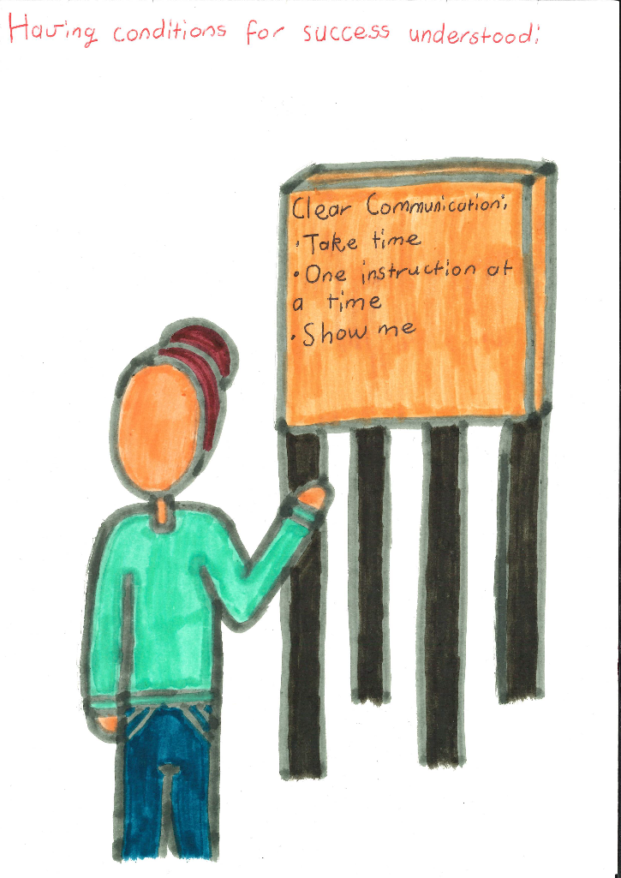

# Your right to know all that's available to you

When you are working with job services and coaches, you might hear something like ‘Is there anything you need from us?’. This often comes up after you’ve landed a job or even while you are applying. But without knowing what kind of help they can offer, it’s easy to feel stuck or say ‘no, thanks’. The truth is, there are so many things available to you that will help you not only get a job but keep it and succeed in it.

If you are not sure what to ask for or, even what kind of support is available to you, it’s totally okay to ask for examples.

Here’s how that could look:

“I got a new job; I start on Monday”

“Great! Is there anything you need from us?”

“I’m not sure, what kind of help can you offer?”

By asking that simple question, you open the door to support you might not have realised was there. Maybe you might need help with getting to work or getting the uniform you need. These could make a big difference in getting and keeping a job. You deserve support so that you can thrive.

Remember: there’s no such thing as a ‘silly’ question when it comes to your future. Asking about support options is a smart way to make sure you have everything you need!



# Your right to access opportunities to build your skills

Your employment service provider has a responsibility to make sure what they offer is accessible for you. You don’t know what you don’t know, and there are lots of opportunities out there to learn new things and strengthen your resume. This can include short courses for certain qualifications, volunteer positions, and employer engagement activities. As a client of an employment agency, you have the right to be included in any activities it offers to young people.

Here are some good questions to ask:

* How can you make sure I am able to take part in these opportunities?
* What can you offer that will help me (insert career goal here)?
* Could you help provide transport to these opportunities?
* Are there any modifications that can be made to suit me?
* Do you offer education support to assist me in getting qualified?



# Your right to have a support person with you

You have the right to bring a support person with you to your job services appointments. This person can help you feel more confident, speak up if you’re not sure what to say, or make sure your needs are understood. Having someone by your side can make a big difference, especially if you’re talking about important things like your goals, challenges, or accessibility needs.

A support person does more than just back you up, they help hold everyone accountable. It reminds your job coach or provider that your goals and needs matter, and that you're there to be listened to and respected. It is also important to remember that even if you have a support person with you, your employment coach or provider should speak directly to you and listen to what you have to say. Your support person is there to make sure your voice is heard and your needs are understood, not replace you. Remember that this is your path and you’re the one making the decisions to shape it!

Bringing someone along can also help open honest conversation and give you the confidence to start self-advocating. Over time, it can make it easier for you to speak up, ask questions, and be more in control of your own journey.

## Who might make a good support person?

* Parent/caregiver
* Support worker
* Friend
* Family member
* Occupational therapist or other professional in your support team.

If you are unable to have someone there in person, that’s okay! You can still get support by having letters written by someone on your support team such as your occupational therapist, psychologist, GP etc. These letters can help explain what kind of support you need to do your best. It’s a great way to help your job provider understand your needs, even if your support person can’t be there with you.

# Your right to make a complaint

You deserve to be treated with compassion and respect. Discrimination, abuse, and neglect is never okay. If you experience any of these with your employment service, it is your right to do something about it. There are official channels for making complaints. Here’s how to do it:

1. Each employment service provider has an official way to make a complaint from within the company. This information can be found on their website, or by asking a member of staff.
2. If you still don’t feel heardand you’re not happy with how the service has handled your complaint, you can make a complaint to the National Customer Service Line or the Complaints and Resolution Referral Line (for disability employment services) directly. This can be done by filling out an online complaint form or contacting:  
   [National Customer Service Line](https://www.dewr.gov.au/about-department/contact-us/complaints/employment-services-complaint-form/making-complaint-about-employment-services) at 1800 805 260 or via email at [nationalcustomerserviceline@dewr.gov.au](mailto:nationalcustomerserviceline@dewr.gov.au)[Complaints and Resolution Referral Service](https://www.jobaccess.gov.au/complaints-or-report-abuse/complaints-disability-advocacy) at 1800 880 052 or via [the online complaint form](https://statics.teams.cdn.office.net/evergreen-assets/safelinks/2/atp-safelinks.html). This is for **disability employment services specifically.**  
   The[Australian Human Rights Commission website](https://humanrights.gov.au/complaints/complaint-guides/complaints-under-disability-discrimination-act) is another good place to not only research your rights but also reach out to make a complaint.

If you would like help with making a complaint, you can contact an advocacy service. You can find many of them throughout Australia through the [Australian Federation of Disability Organisations website.](https://afdo.org.au/resource-disability-advocacy-organisations/)



# Your right to change employment services

It is your right to change employment services for whatever reason, at any time, as many times as you want. You don’t have to have a bad experience at your employment service to decide it’s not for you. The best way to do this is to:

1. Find a new employment service provider that is better suited to your needs. For guidance, check out our employment service red and green flags (see below).
2. Contact the new provider in whatever way is best for you, whether it be by email, phone, or in person.
3. Once you’ve introduced yourself, and checked if there’s a space for you, you can simply transfer through the Workforce app, or through the National Customer Service line on 1800 805 260. The new provider might be able to help you with this.

You can change employment services without contacting your old employment service. If you need a pause on your job search you can contact your GP or your employment service provider. For more information, check out these links:

[How do I change my Workforce Australia provider? | CoAct](https://coact.org.au/how-do-i-change-my-workforce-australia-provider/)

[Guide to transferring DES providers - Easy to follow step | CoAct](https://coact.org.au/transferring-des-providers-guide/)

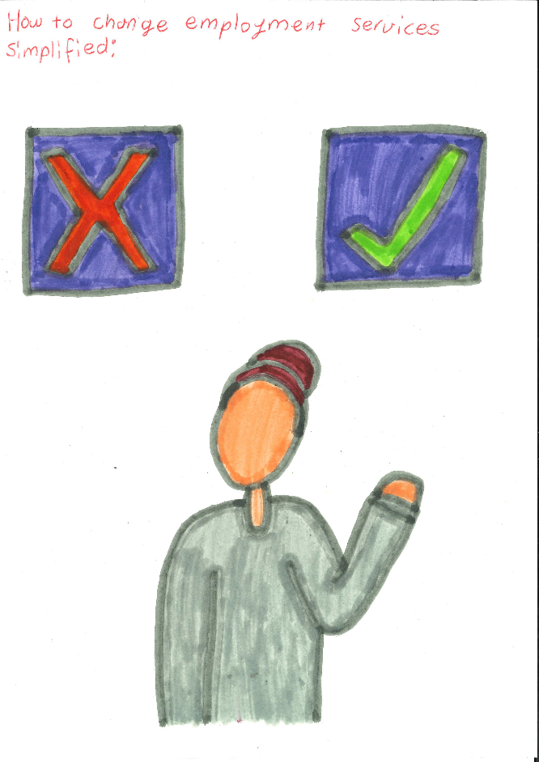

# A hand drawn picture of a person holding up a red flag and a green flag. How to evaluate job providers: spotting red and green flags for the support you deserve

When it comes to job providers, it can be hard to tell if what you're experiencing is "normal" or not. The truth is that you have the right to make an informed choice about the support you're getting. You deserve guidance that is tailored to you and helps you get where you want to go.

Here’s a list of some common ones:

## **Green flags**

* They show understanding and flexibility with your appointment – such as scheduling, or whether you prefer in person or on the phone.
* You feel listened to.
* They believe in you and your career goals.
* They have connections to great jobs, opportunities and communities.
* The service takes a person-centered approach, tailoring their support to your specific needs.
* They are able to show evidence of success in gaining clients employment.
* You feel comfortable voicing your needs and sharing your goals.
* The information is provided in a way that is accessible to you.
* They actively offer and provide ways to build your skills and explore new opportunities.
* The space itself is welcoming and inviting. You feel at ease when you walk into the office.
* Making decisions **with** you rather than **for** you.
* On~~-~~going support is available to you after you get a job.
* They offer and provide help with resumes, interview skills or applying to jobs.

### **Red flags:**

* Lack of knowledge of disability (including invisible disability).
* Being told to apply for jobs that don’t align with career goals or conditions for success.
* You feel dismissed, like an outcome or number rather than a person.
* They often rely on stereotypes rather than considering your unique circumstances.
* You are only pushed towards unpaid opportunities.
* The service and your appointments feel clinical and like ticking boxes rather than focusing on you as an individual.
* Your appointments feel rushed, like there's not enough time to focus on what you want or need from them as job providers.
* The office is not inviting, what to do when walking in is unclear and makes you feel uncomfortable or confused.
* You are not supported after getting a job.
* There is only a focus on getting you a job not finding one that’s the right fit for you.
* You feel discouraged from applying to jobs that don’t fit what they believe in as success.
* Frequent delays, cancellations, or last-minute changes with appointments leaving you feeling unsupported and unable to rely on them.
* You feel as though your information is not being kept private or confidential.